 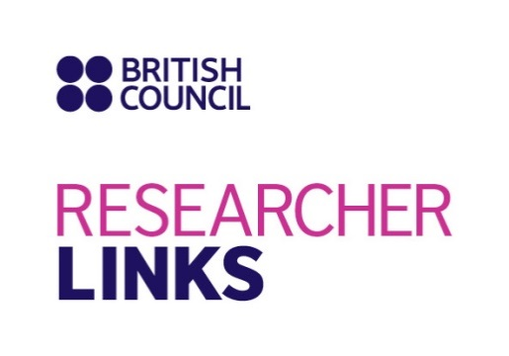 

**Workshop Title: UK-China Childhood Respiratory Disease Workshop**

**UK coordinator: Professor Rosalind Smyth, UCL Great Ormond Street Institute of Child Health, UK**

**Partner Country coordinator : Professor Enmei Liu, Children’s Hospital, Chongqing Medical University, China**

**Discipline: Clinical Paediatrics, Biological Sciences, Epidemiology, Social Sciences.**

**Dates and venue: 15-18 October 2018 in Children’s Hospital, Chongqing Medical University, China**

The programme, ‘British Council Researcher Links’ provides opportunities for early career researchers from the UK and internationally to interact, learn from each other and explore opportunities for building long-lasting research collaborations.

As part of this programme, we are now recruiting early career researchers to participate in the above workshop.

The workshop will provide a unique opportunity for sharing research expertise and networking. During the workshops early career researchers will have the opportunity to present their research in the form of a poster/short oral presentation and discuss this with established researchers from the UK and partner countries.

The British Council and the National Natural Science Foundation of China will cover the costs related to the participation to the workshop, including: travel (both international and local), accommodation and meals. Costs for the visa, and travel insurance will be covered; however participants will be responsible for making all the necessary arrangements. The British Council accepts no responsibility for any problems which may occur when the participants are in-country.

**Application and Deadline: Thursday, 31st May 2018**

The full application below must be completed and submitted by Thursday, 31st May 2018 to: [workshop151018@sina.com](mailto:workshop151018@sina.com)

**Eligibility Criteria:**

* Applications must be submitted using the Researcher Links application form
* Application must be submitted before the above deadline
* Participants must be Early Career Researchers: Early Career Researchers are defined as holding a PhD and having up to 10 years post-PhD research experience. They are equivalent to the ‘Recognised Researcher’ and sometimes ‘Experienced Researcher’ categories in the EU framework for researchers’ careers. <https://euraxess.ec.europa.eu/europe/career-development/training-researchers/research-profiles-descriptors> .
* Participants must have a research or academic position (a permanent post, research contract, or fellowship etc) at a recognised research institution either in the UK or in China.
* Please note that participants are expected to attend all sessions of the workshop.

**Quality Assessment**

* Experience and relevance of the applicant’s research area to the workshop
* Motivation and contribution to the aims of the workshop
* Description of the long term impact expected through the participation in the workshop
* Ability to disseminate workshop’s outcomes

**Selection Procedure:**

* Eligibility check
* Quality assessment

**Notification of results:**

Applicants will be notified by email 2 months prior to the workshop.

**Equal Opportunities**

Equal opportunities and diversity are at the heart of the British Council’s cultural relations ambitions. While recognising that some research fields are dominated by one particular gender, co-ordinators are encouraged to work towards an equal gender balance, promote diversity. They must not exclude applicants on the basis of ethnicity, gender, religious belief, sexual orientation, or disability. Participants’ selection undertaken by workshop organisers must not contravene this policy. Extra support to enable participation of Early Career Researchers with special needs will be given.

Workshop Application Form

|  |  |
| --- | --- |
| **1. Applicant** | |
| Name and title |  |
| Gender (for statistical purposes. This will not affect choice of participants) |  |
| Position and institution |  |
| Postal address |  |
| Email |  |
| Phone number |  |
| Brief CV (academic career, publications, markers of esteem, and any other relevant information) – no more than ½ page of A4 |  |

|  |
| --- |
| **Abstract -** Please give a summary of your area of research |
|  |

|  |
| --- |
| **3. Please describe your motivation for attending the workshop and how the workshop matches your professional development needs** |
|  |
| **4. Please describe the expected impact of your participation on your personal and professional development, including your ability to work internationally** |
|  |

|  |
| --- |
| **5. Please indicate how you will disseminate the outcomes of the workshops and the new knowledge/skills you have acquired** |
|  |

|  |  |  |  |
| --- | --- | --- | --- |
| **6. Workshops will take place in English as standard. Please indicate your ability to work and communicate in English (Note, translators may be provided if necessary)** | | | |
| Native speaker |  | Good |  |
| Excellent |  | Need support |  |

|  |
| --- |
| **7. Please use this space to give any additional information that you feel is relevant for the application.** |
|  |